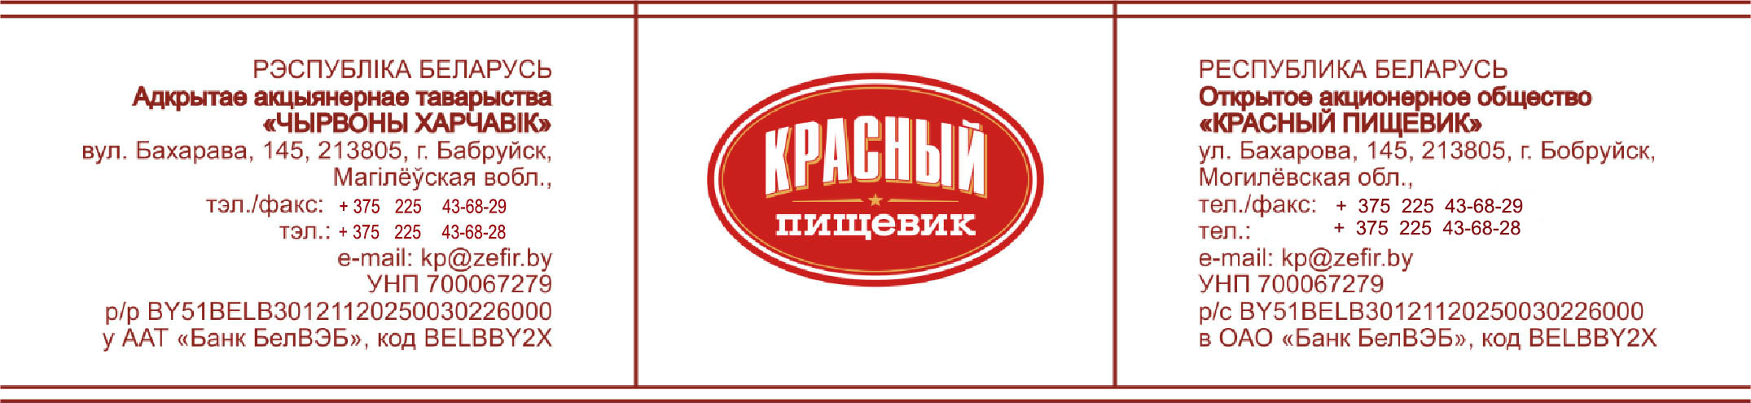

Commercial offer

OJSC «Krasny pischevik» invites to cooperation companies carrying out activities in the sphere of import and realization of confectionery.
OJSC "Krasny pischevik" is a modern confectionery enterprise of the Republic of Belarus. The history of the enterprise begins in 1870. The confectionery factory produces zephyr, toffee, dragee, marmalade, iris, brittles, halva and paste, chocolate candies with jelly and whipped bodies, as well as products without added sugar (zephyr, halva and dragee). The assortment list includes more than 180 species. Production capacities allow producing more than 15 thousand tons of confectionery products per year.
All products are made according to classical technologies using natural raw materials, so they have unique taste, food and biological value. The company's specialists constantly work to expand the range of products taking into account market requirements, improvement of packaging materials and design.
There is a system of a quality management of designing, development and production of confectionery products, corresponding to the requirements of STB ISO 9001-2009, the HACCP food safety system.
OJSC «Krasny pischevik» distributes its products to Russia, Ukraine, Kazakhstan, Armenia, Azerbaijan, Uzbekistan, Georgia, Israel, the USA, Canada, China, Lithuania, Latvia and other countries of near and far abroad.
HS Code on production of the enterprise:
№ | Product name | HS Code
1 | Zephyr, marmalade (not glazed with chocolate icing) | 1704906500
2 | Zephyr, halva (glazed with chocolate icing) | 1806903100
3 | Halva, Paste, Brittles (unglazed) | 1704909900
4 | Candies (glazed with chocolate icing) | 1806901900
5 | Dragee (glazed with chocolate icing, cocoa-powder) | 1806905009
6 | Dragee (not glazed with chocolate icing, cocoa-powder) | 1704906100
7 | Toffee (without the addition of cocoa-powder) | 1704907500
8 | Zephyr without sugar, Halva without sugar,  Dragee without sugar | 2106909809

OJSC «Krasny pischevik» offers flexible terms of cooperation with an individual approach to each Buyer. If needed the enterprise prepares the certificates of origin of goods in Belarusian Chamber of Commerce and Industry. At the request of the Buyer, the enterprise produces confectionery under own brand with stickers in the language of the country of destination.

Terms of delivery – FCA Bobruisk, Republic of Belarus.
Terms of payment – 100% advanced payment.
Customs clearance in the territory of the Republic of Belarus is carried out at the expense of the enterprise.
The period of order’s execution is from 5 to 10 days.
Prices and product information can be found in the attached price list, presentation and at the website of the company – www.zefir.by

Company address and contact information:

OJSC «Krasny pischevik»
213805, 145 Baharova str., Mogilev region, Bobruisk. Republic of Belarus

Export Sales Department – tel: +375(225)482731, e-mail: export@zefir.by

Deputy Head of Export Sales Department Bogdan Himakov
Tel +375297646058, +375296850154, e-mail: himakov_export@zefir.by

Export Sales Specialist Robert Scheer
Tel +375295036337, +375447604019, e-mail: rsheer@zefir.by

Export Sales Specialist Elena Glukhovtsova
Tel +375295037270, +375296544627, e-mail: elena-export@zefir.by

We hope for mutually beneficial and long-term cooperation.

